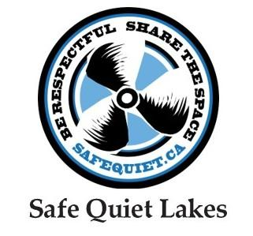
YES! I want to help expand the conversation about respectful and responsible boating.

Please complete this form and mail it with your cheque payable to Safe Quiet Lakes to:
Safe Quiet Lakes - P.O.Box 358 Rosseau, ON - Canada, P0C IJ0

To donate via e-transfer, please send to donate@safequiet.ca. Don't forget to leave your name and email address in the notes so we know who the donation came from.

Contact Name: _________________________________________________________________________
Home Address: _________________________________________________________________________
City: ___________________________ Province: _______________ Postal code: ___________________
Daytime phone: ________________ Email: __________________________________________________
If this donation is on behalf of an association, please provide e-mails for your executive so we can send you newsletters & invitations to our stakeholder meeting and other events.

Lake Association: _______________________________________ Township: _______________________
President’s name:_______________________Email:_____________________________________________ Communications or Lake Steward name: ___________________ Email:_______________________
Treasurer’s name: _______________________Email:____________________________________________
AMOUNT
☐ Platinum - $2000
☐ Gold - $1000
☐ Silver - $500
☐ Supporter- $250
☐ Supporter - $100
☐ Other: _______
Donors may be recognized in print or online materials. Please indicate your choice:
Name for Recognition purposes: ________________________________________ or ☐ Anonymous
Subscribe to our newsletter?
☐ Yes, I would like to receive email communications from Safe Quiet Lakes ☐ No thanks
Many thanks for your support!

